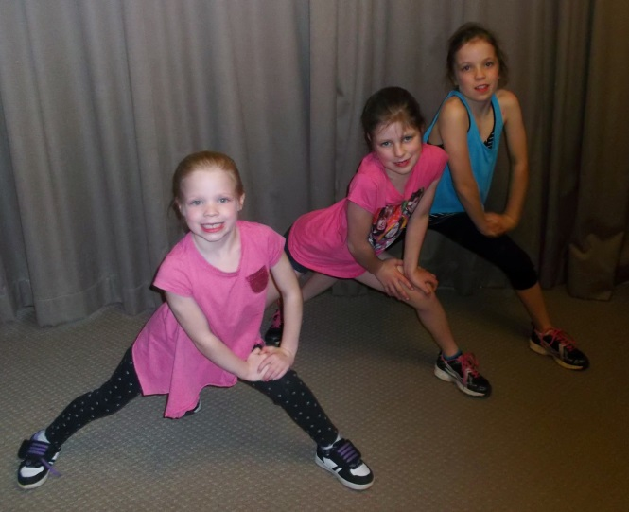
STUDENT FEEDBACK
“Thank you for helping me learn some of your moves in Energize. It was absolutely awesome. I loved my pose. It was excellent”
“Thanks for teaching us Energize. I like the push ups the most. I really enjoyed it. Thank you”
“Thank you for coming to this school this term and being our instructor. I really loved it. What I like was the movements.”
“Thank you for showing and helping us learn all the moves of Energize. Thank you for helping all of us get the moves right for the big performance. Thank you also for running us through all 10 lessons. I would love to do it again”
“I really like doing Energize because if gets you moving. I learned a lot in the last 10 weeks. I really like the routine and the performance. I enjoyed every second of it”
“Thank you for all your hard hard effort into helping us do all our moves on time and listen to the beat of the music”
“Thank you for teaching me Energize. I’ve learnt a lot in energize and enjoyed myself. I can’t wait until the energize performance. Thank you”
“Thank you for teaching us the dance steps. Doing the routine was fun. I was very confident that I had all the dance steps right. Last year I went really well but this year most of my moves improved. Thank you for your effort on teaching us the dances. It was really energetic”
“Thank you for doing a fantastic job for making up our routines. I really enjoyed our hour sessions”
“Thank you for teaching us Energize. This year you were even better than last year. Thank you for making me confident doing dancing to the beat”

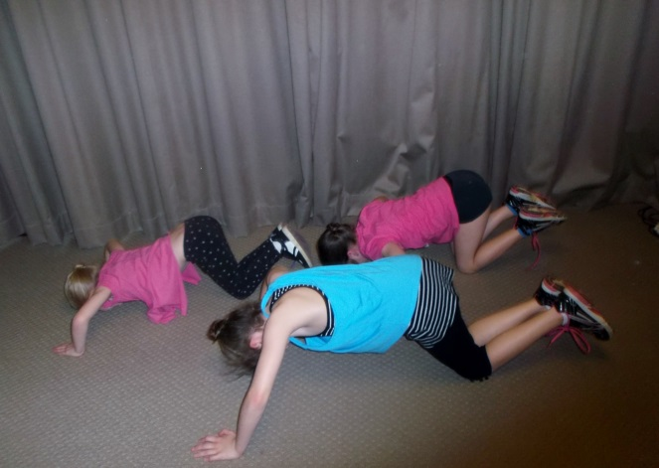
“Thank you for choreographing such a good routine. Energize has made me have more confidence than ever. My favourite step would have to be the runs”
“Thank you for an amazing programme which helped us improve our skills. My favourite step was the side behind side dig and learning new moves every week. I hope it continues now and next year”
“Thank you for organising Energize. This year I think I improved my timing of my steps. PS I loved Energize this year”
Thank you for teaching us our Energize routine. I think you are a great choreographer. I really think Energize has helped me in confidence, self-esteem and being in time. That helps me to play my guitar in time. My favourite dance move is the grapevines. I really hope it happens again”
“Thank you for organising this energize programme. It was an amazing day at the concert”

